Faculty Guide
  - Faculty Service Credits

How To

Activity Entry
To access the Activity Entry page, go to https://portal2.tri-c.edu/FacultyServiceCredits.

Top Section
The top of the page has controls, status messages, and totals:
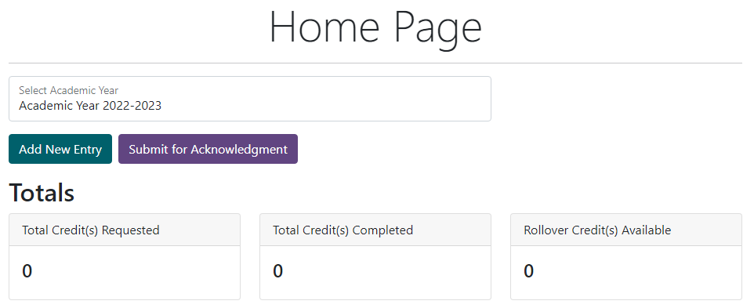
- Academic Year: The active academic year is displayed in the drop-down at the top. It defaults to the current year.
- Buttons: The next line displays available buttons.
- Status Message: The next line displays a status message based on the most recent activity (defaults to blank).
- Totals: The Totals section displays total credits request/completed, and available rollover credits.

Activities Section
The Activities section displays the activities you’ve added for the current academic year:
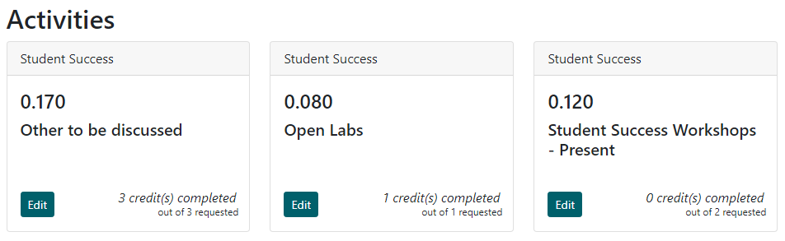
The cards display in rows of 3. Each card represents a single activity and includes (in order), the activity category, the activity ID, the activity name, and the credits completed/requested.

Entering a New Activity
- Go to the application’s home page at https://portal2.tri-c.edu/FacultyServiceCredits.
- Click the Add Entry button. The Add Entry page appears:
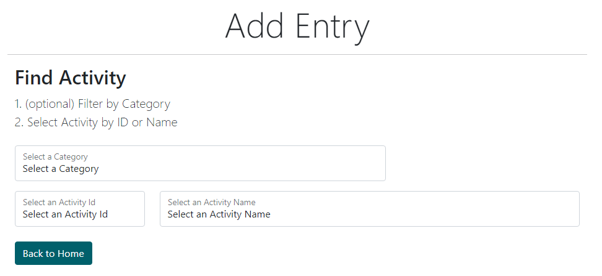
- Use the filter and selection controls to select an activity. Note you can type once a box has been clicked on in order to find a selection. Once you’ve selected an activity you can still change it, but any details you enter below will be lost. You may also click “Back to Home” to return to the Home Page.
- Once an activity is selected, additional info about it will be shown below the ID and Name:
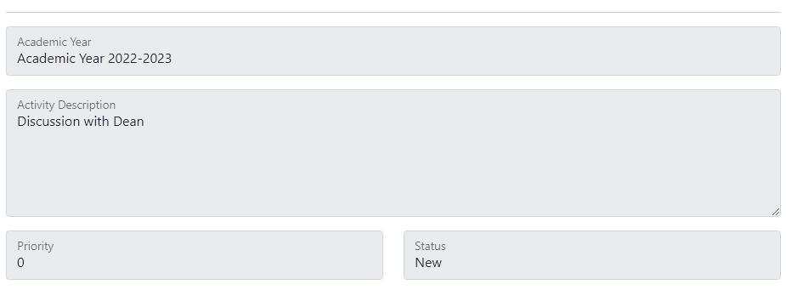
- Below that, the “Enter Details” section will appear.
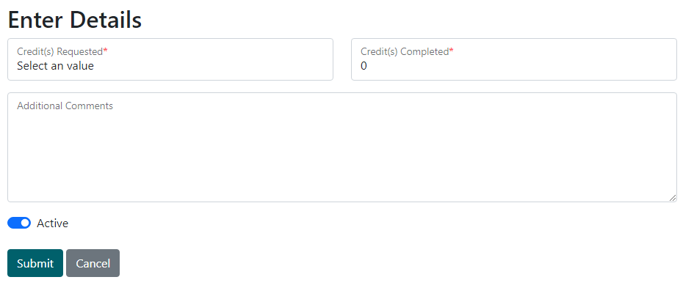
- Enter the relevant information and click Submit. The following message appears. You can either enter a new activity or click “Back to Home” to return to the Home Page.
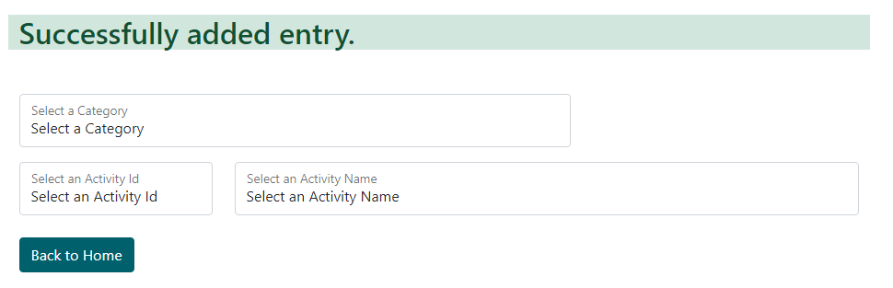

Editing an Existing Activity
- Go to the application’s home page at https://portal2.tri-c.edu/FacultyServiceCredits.
- Identify the activity to be edited and click the Edit button in the bottom left of the card.
- The Edit Entry page appears. This page is exactly the same as the Add Entry page, except the activity cannot be changed. The “Edit Details” section matches the “Enter Details” section from the Add Entry page, and can be updated as needed, then submitted.

Activity Submission
Activity entries are not automatically visible to your dean. You need to submit them first for acknowledgment, and later for acceptance.

Submitting Activities for Acknowledgment
- On https://portal2.tri-c.edu/FacultyServiceCredits, click the Submit for Acknowledgment button under the Academic Year display at the top of the page:
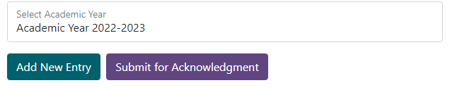
- The following success message and status information display. The “Submit for Acknowledgment” button has changed to “Submit for Acceptance.”
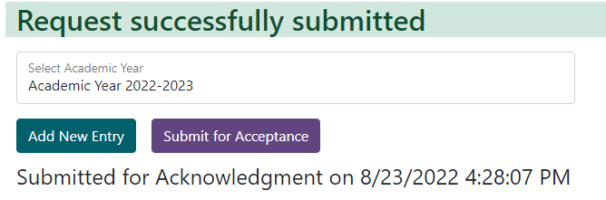

Submitting Activities for Acceptance
- On https://portal2.tri-c.edu/FacultyServiceCredits, click the Submit for Acceptance button under the Academic Year display at the top of the page:
- The following success message and status information display. Your activities are no longer editable.
