Approver Guide
  - Faculty Service Credits

How To

Activity Approval

Accessing the Approval Page
- Go to the application home page at https://portal2.tri-c.edu/FacultyServiceCredits.
- If available, click on Approval Page to the right of the Academic Year display. It will only be visible if you have Acknowledgment or Acceptance records that were submitted to you for the current academic year.
- The Approval Page appears with a list of requests that were submitted to you:
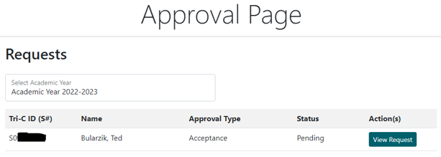

Viewing a Request
- From the Approval Page, click View Request next to the record you’d like to approve. Or, if you have the notification email, you can click the direct link provided (similar to https://portal2.tri-c.edu/FacultyServiceCredits/Approval/Approval/11). The Approval Request page appears:
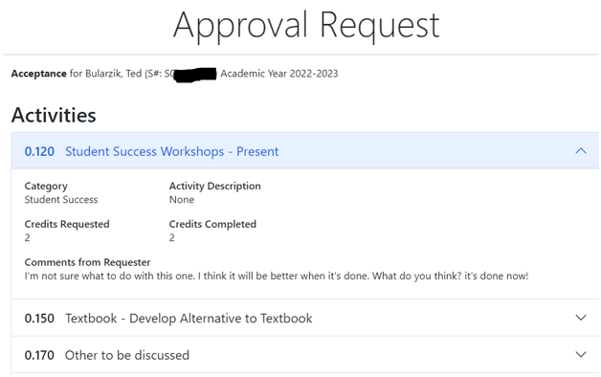
- Each activity entered by the requester is represented by an expandable accordion section. The first one is expanded by default. Expand each section to view the details of the activity, the credits request/completed, and any comments entered by the requester.
- If this is an Acknowledgment, there is no additional action to be taken. You can click “Back to List” at the bottom when done. If it’s an Acceptance, continue to the next section.

Accepting a Request
- On the Approval Request page, scroll down past the accordion to the Additional Comments section:
- Enter any notes in the Additional Comments section. These will be sent to the requester.
- Under “Accept?” choose Yes or No. “Yes” means that the faculty member’s service credits are accepted for the year and they can no longer add or edit activities. “No” means the service credits are not accepted, and will open up the academic year back up for them so they can add and edit activities.
- When ready, click Submit. A success message appears:
OR

Resetting a Request
- Once a request has been accepted, you can still “reset” it so the requester can make changes and resubmit. From the Approval Page, click “View User Request” next to the approval you’d like to reset. The Approval Request page appears.
- Scroll down to the bottom and click on the “Reset Acceptance” button:
- A success message appears. The requester can now edit their entries again.

