Nolan, Amanda
Cuyahoga Community College

Course-level
Assessment manual

Background
We know all courses undergo assessment; no one teaches a class and never tweaks anything based on student needs, industry changes, or technology changes, etc. We as a College just need a way to prove to our accrediting bodies, the Higher Learning Commission and ODHE, that assessments are happening and affecting change, if needed.
Purpose
We want to focus on our ongoing commitment to improve student learning. Through this, we will begin to develop, document, and implement a systematic approach to assessment that leads to institutional improvement. Assessment results will provide departments an opportunity to engage faculty in professional development, dialogue and, most importantly, the occasion to discuss curricular improvements based on assessment results within the department.
Steps to take to create and implement an assessment plan
- Select your team to lead course-level assessments in your discipline.
  - This team will help you champion the project to your other faculty
- Create an assessment plan for all course outcomes. See page 3 for detailed instructions.
  - Even if you just list all outcomes for the course, this plan will help you see what you’d like to assess first. Start with the easiest outcome to assess for your first year.
- Select ONE outcome from ONE course to assess
  - Select an outcome that will be the easy to assess. The first year is about refining your assessment process as much as it is about the assessments themselves.
- Create a rubric for assessing the outcome
  - The rubric should assess the course outcome. That way, all assignments will work for the same rubric, even if you only use a part of the assignment or a question or two from a test.
- Communicate to your fellow faculty about the assessment cycle and what their steps are to participate (align in Blackboard, collect data, etc)
  - The Assessment Office can create a communication plan customized for your discipline. We can map out the year for your faculty so they know which task is coming up each month, when assessments starts, etc.
- Start collecting assignments via alignments
  - Aligning assignments (also known as artifacts in Assessment) in Blackboard only takes a few quick clicks! See page 10 for more detailed information.
- Start assessing artifacts
  - Once your artifacts are collected, your team and any other discipline faculty you’d like can begin comparing the artifacts against the rubric and entering your results in the Data Results column of your assessment plan
- Discuss the results
  - If your results are below your chosen benchmarks, discuss what changes will be made to increase your results for the next time you assess this particular outcome. More homework, more lectures on a given topic, new assignments to assess the outcome, etc.
- Implement any changes to the plan, assignments, outcomes, etc
  - Start trying out the changes your data led you to make.
- Document changes and/or results with the Assessment office for safe keeping for the HLC reports
  - There will be an online form to complete at the end of next summer to report:
    - Course
    - Assignment/Artifact types used
    - Benchmark met/not met
    - Changes implementing in Fall
SAMPLE ASSESSMENT PLAN
Course Learning Outcome | Assessment Tool/  Assignment  (Artifact) | Assessment Cycle | Benchmarks | Data Results | Data Review | Action Plan | Date Completed
Safely administer effective treatment | -Essay  How do you assess this? | -Collect in Fall, Assess in Spring  You should assess 2 or 3 outcomes each year | 80% pass rate  What does success look like for this outcome? | 75% have passed  This would be entered after you assess your criteria | Faculty meeting in Spring  Please enter when you will review the Data | Add additional Safety assignment  What will you change if your results are too low? | 5-17-20

- Course Learning Outcomes:
  - Simply list all Course Learning Outcomes (listed in the College catalog)
- Assessment Tools/Assignments:
  - What are you using to assess your outcomes? An assignment? Surveys? Labs? Quiz questions?
- Assessment Cycle:
  - When do you assess? Once a year? Once a semester? 9 months after graduation?
- Benchmarks:
  - What level of success do you want to achieve in your assessments? 90% satisfaction? 80% get a B or above? 75% pass on the first attempt?
- Data Results:
  - What were the results of your assessments?
- Date Review:
  - When is the best time for your faculty to discuss the results of your assessment?
- Action Plan:
  - What actions will you take to achieve your goal if your results are lower than your desired benchmark?

Below is a timeline of tasks to accomplish. The following pages have in-depth checklists. At the end of this document are guides to create assignments in Blackboard, align assignments, and evaluate assignments.
Summer/Fall
Summer/Fall
FALL
SPRING
Spring/ Summer
Fall

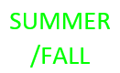
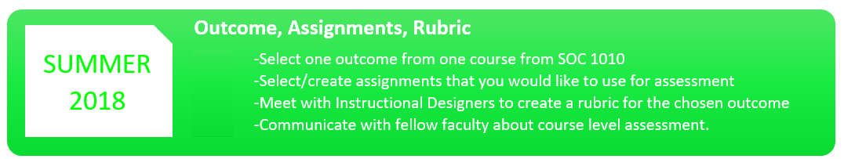

Create one rubric that will cover all assignments.

The rubric should pertain directly to the course-level outcome you have chosen.

CLOA, LOA, and CLE are available to assist with rubric creation
Select one outcome from one course to begin your project

Suggested courses include:
-Highest enrollment courses
-Courses with different modalities
-Courses that will get the highest faculty participation

Please have your faculty select one assignment that applies to your chosen outcome
OR
Create a sample assignment for all faculty to use
OR
Choose another way to assess your outcome (Standardized quiz, self-reporting data, etc.)
Rubric
Assignments

Faculty Communication
The assessment office can provide each assessment group with information on:
- FAQ sheet about assessment that can help guide the introduction of the project and subsequent discussions counterparts meetings.
- Best assessment practices
- How-to guides for using Blackboard Outcomes
- A detailed plan of assessment, individualized for your department
- Assessment procedures outside of Blackboard

Course and Outcome
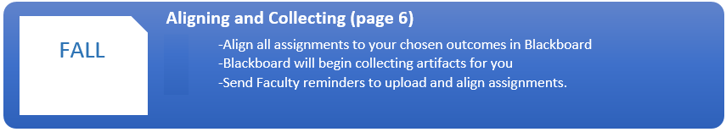
Faculty reminders:
Date Sent:

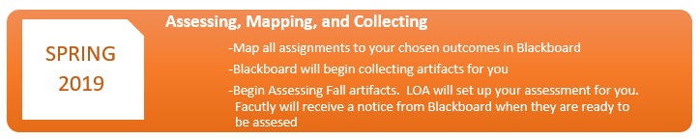
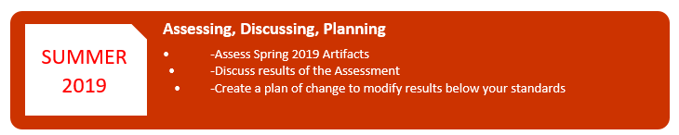

Assessments due:
Assessment information

Improvement Plan

Assessments due:

